Full Stack Development with MERN Project
Documentation

1. Introduction
- Project Title: ShopEZ
- Team Members:
Name | Role
Geeta Rani | Frontend Development, Backend Development,  Database Management, Testing

2. Project Overview
Purpose :
ShopEZ is a full-stack e-commerce web application developed to simplify the process of browsing products, managing a shopping cart, and shopping online. Traditional shopping experiences can be scattered across many platforms, making it hard for customers to compare products and complete purchases quickly. This system provides a single, lightweight platform where customers can view a curated product catalog, add items to a cart, and check subtotal pricing in their preferred currency.
The platform also provides secure, JWT-based authentication so customers can register and log in to access a personalized profile. The system ensures secure password storage using bcrypt hashing and protects authenticated routes such as the user profile endpoint.
Features :
- Product Catalog Browsing
- Product Detail Retrieval
- Shopping Cart Management (Add / Update / Remove)
- Customer Registration and Login
- Secure JWT Authentication
- Password Hashing with Bcrypt
- Multi-Currency Price Switching
- User Profile Retrieval
- Session & Cart Persistence
- Responsive Bootstrap 5 UI

3. Architecture
Frontend Architecture :
The frontend of ShopEZ is developed using React.js and Vite. React components handle UI elements such as the product grid, cart view, and authentication forms, styled with Bootstrap 5. Axios manages communication between the frontend and backend APIs. Application-wide state — cart contents, logged-in user, and selected currency — is managed through a shared React Context store.
Backend Architecture :
Node.js and Express.js frameworks are used for the backend. REST APIs handle product retrieval, authentication, and profile access. While route handlers contain the request logic, JWT middleware validates the Authorization header for protected endpoints such as fetching the current user.
Database Architecture :
The database chosen is MongoDB (with MongoDB Atlas for cloud hosting, and a MongoDB in-memory server as a local development fallback). It stores user account data, while the product catalog is served from a structured in-memory data set representing the Product model.
System flow:
1. The customer visits ShopEZ and the frontend fetches the product catalog from the backend.
2. The customer can browse products, view prices, ratings, discounts, and seller information.
3. The customer registers by providing a name, email, and password, or logs in with existing credentials.
4. On successful registration/login, the backend issues a JWT token which is stored on the client.
5. The customer adds products to the cart, adjusts quantities, or removes items — state is managed client-side and persisted.
6. The customer can switch the displayed currency to view converted product prices.
7. The customer's profile can be retrieved from the backend using the stored JWT token.

4. Setup Instructions
Prerequisites
Before running the application, ensure the following software is installed:
- Node.js v18 or above
- npm
- MongoDB Atlas Account (or local MongoDB)
- Git
- VS Code
Installation Steps:
Clone Repository:
git clone <repository-url>
Install Backend Dependencies:
cd backend
npm install
Install Frontend Dependencies:
cd frontend
npm install
Environment Variables:
Create .env in the backend folder:
PORT=5000
JWT_SECRET=your_secret_key
MONGO_URI=your_mongodb_connection_string
Create .env in the frontend folder:
VITE_API_URL=http://localhost:5000/api

5. Folder Structure
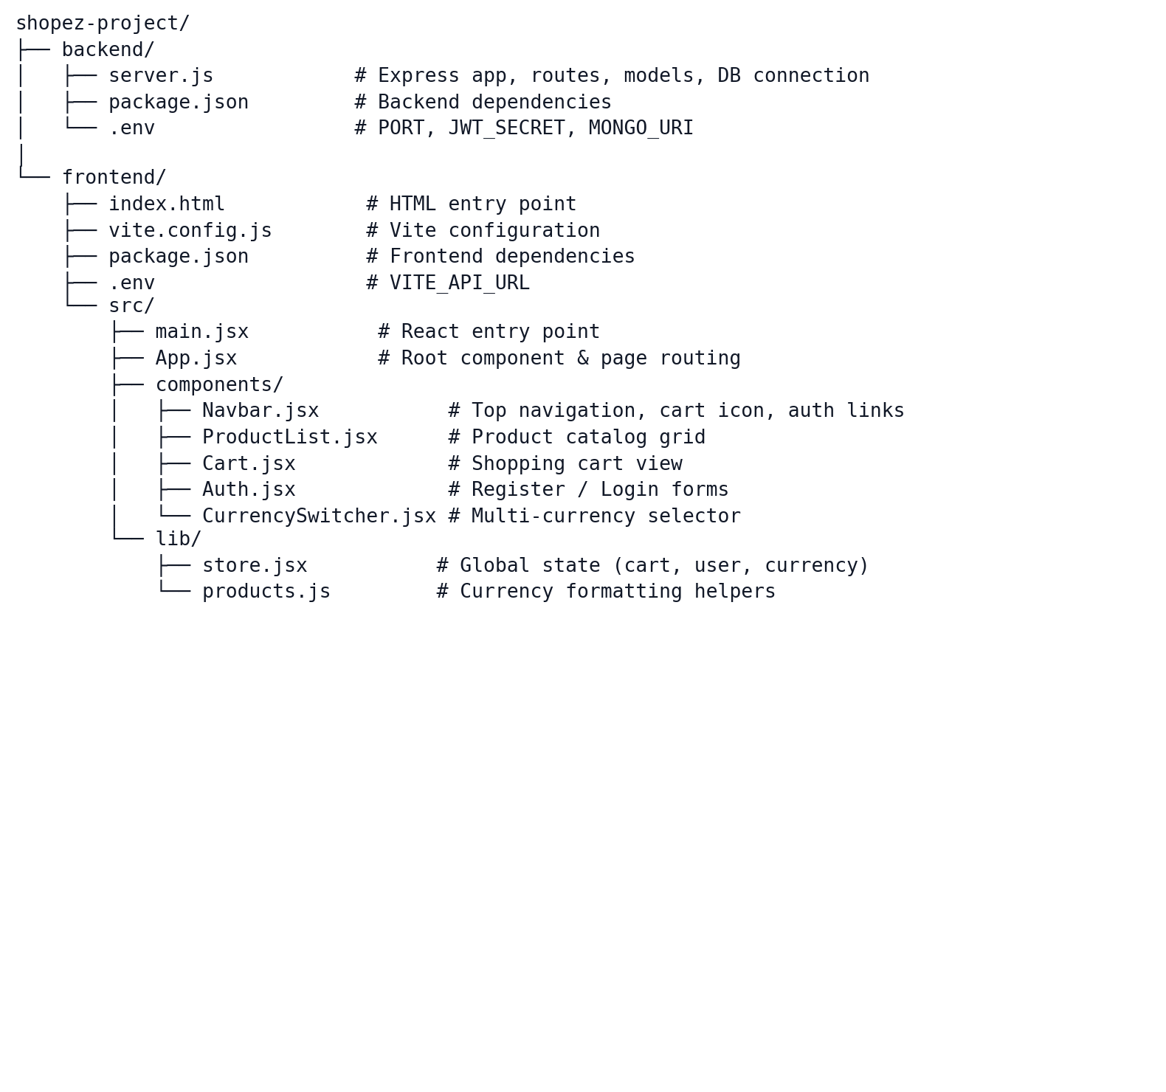

6. Running the Application
Start Backend
cd backend
npm run dev
Backend URL:
http://localhost:5000
Start Frontend
cd frontend
npm run dev
Frontend URL:
http://localhost:5173

7. API Documentation
Health Check
GET /api/health
Product APIs
Get All Products
GET /api/products
Get Single Product
GET /api/products/:id
Authentication APIs
Register User
POST /api/auth/register
Login User
POST /api/auth/login
Get Current User
GET /api/auth/me

8. Authentication
The ShopEZ application uses JWT (JSON Web Token) based authentication to protect user sessions. Once a user registers or logs in successfully, a JWT token is issued and stored on the client-side. It is sent along with future requests (such as fetching the profile) for authentication purposes.
Some security practices employed include:
- Password hashing with bcryptjs
- JWT Authentication
- Protected profile route
- Secure API validation
- CORS configuration

9. User Interface
Home Page / Product Listing :
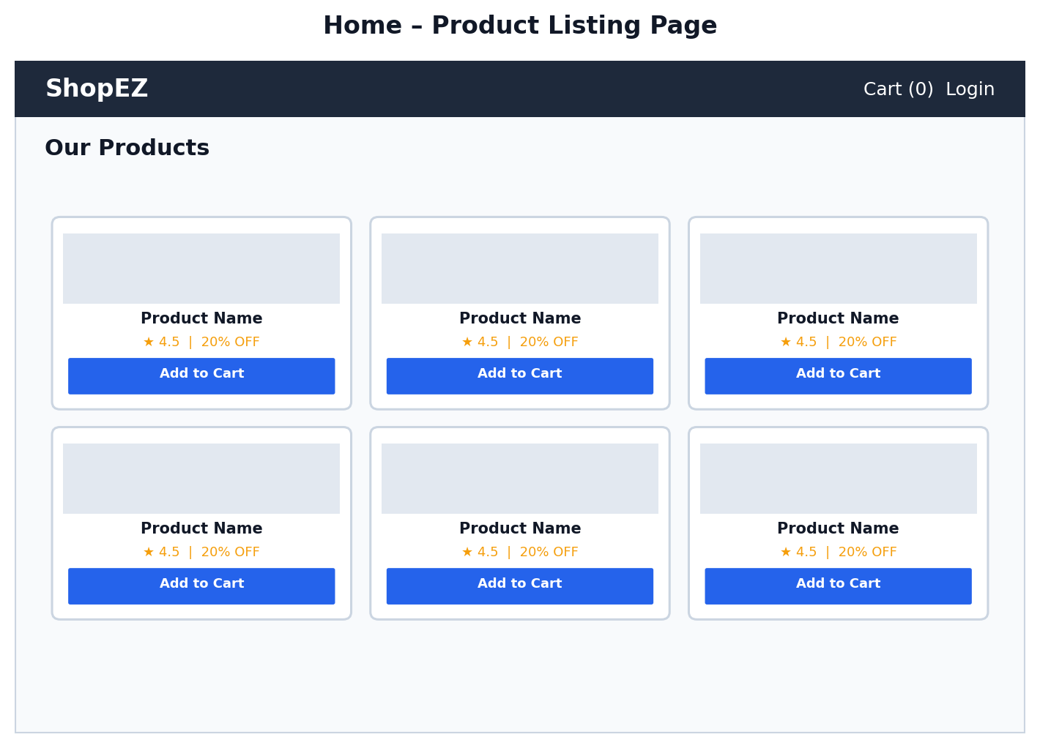
Shopping Cart :
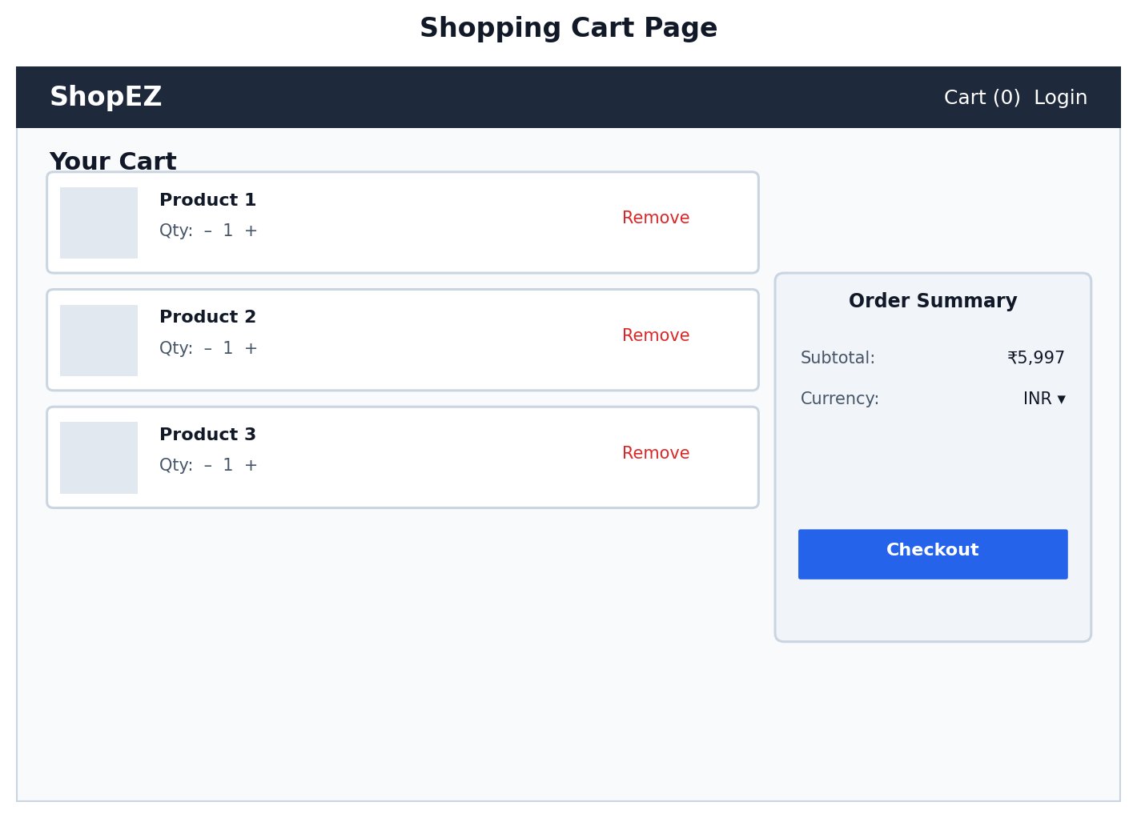
Register / Login Page :
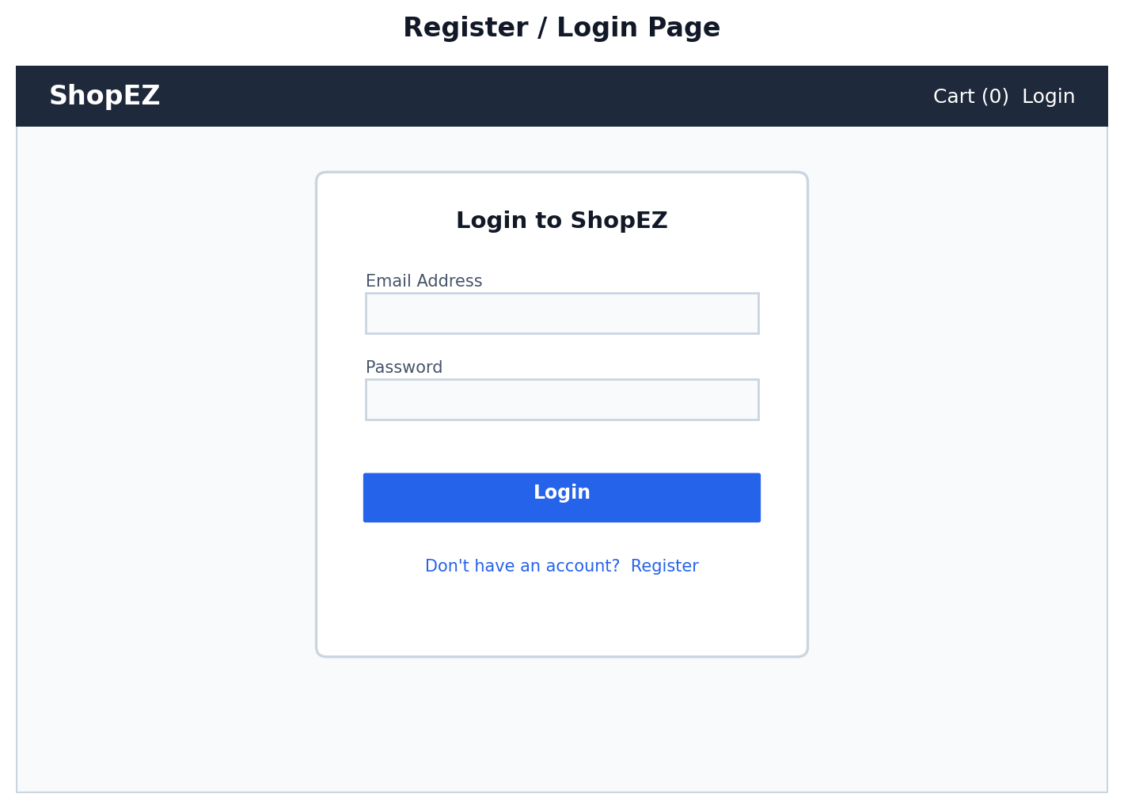

10. Testing
Testing was performed to ensure system reliability and functionality.
Functional Testing
Verified all modules work according to requirements.
Authentication Testing
Verified registration, login, token validation, and profile retrieval.
Cart Testing
Verified add, update quantity, and remove cart workflows.
UI Testing
Verified responsiveness and usability across different screen sizes.

11. Screenshots or Demo
Project Demo Link :
[Add your project demo / repository link here]

12. Known Issues
- Payment gateway integration is not implemented.
- Order history and tracking are not available.
- Product search and category filtering are not implemented.
- Product reviews and ratings cannot be submitted by users (ratings are static demo data).
- Wishlist functionality is unavailable.

13. Future Enhancements
Future improvements planned for ShopEZ include:
- Payment Gateway Integration
- Order Placement and Order History Tracking
- Product Search and Category Filtering
- Customer Product Reviews and Ratings
- Wishlist / Save for Later
- Seller Dashboard for Product Management
- Admin Dashboard for Platform Monitoring
- Email Order Confirmation Notifications
- Mobile Application
- Real-Time Currency Conversion via Live Exchange Rates

